Based on the primery data and the secondery data that was colected through deferant techniqes their was some chalanges such as pollotion that is coused by the supplements jars which

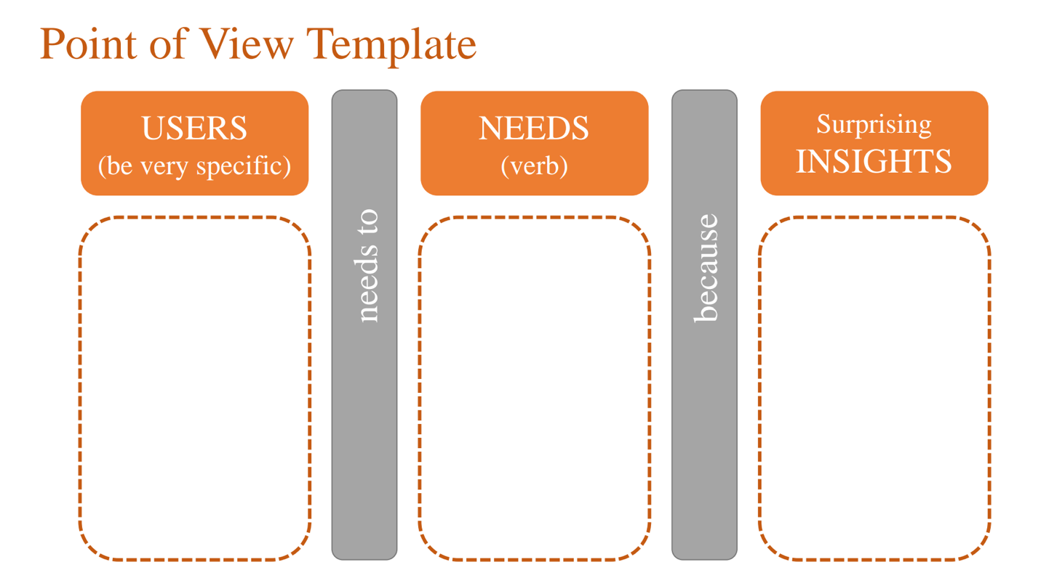

These cafeterias often face challenges in quickly weighing supplement doses in grams which takes some time and makes the customer wait, and potential waste and loss from spillage And the lack of demand for some supplement

To efficiently serve a high volume of customers in a way that minimizes service time and reduces product losses."

Cafeterias which are located in Gyms that serve fitness supplements.

POV Statement:

Gym cafeteria managers need a way to reduce the time and product loss involved in weighing supplement doses because even though supplements are in high demand, the current process leads to inefficiencies that increase wait times and customer dissatisfaction.

How might we achieve high accuracy in weighting supplement doses in a faster way than the traditinal way or how we can elimenate the weighting part?

How we might we get a full use of all kinds of supplements and achive the highest profit with the least losses?



A simple and easy preparation method also needs a variety of supplements and flavors at an affordable cost."

End users who like to have their supplements in their homes.

End users prefer purchasing multiple supplements in small, affordable quantities with diverse flavors rather than large amounts of a single supplement in one flavor.

POV Statement:

End users need a way to afford a variety of supplements in smaller, more manageable quantities because they prefer to experiment with different flavors and supplement types without the need large-volume purchases.

HMW simplify the prosces of preparing any supplemts?

HMW offer supplements in smaller amounts that allows the user customize their supplemnts types and flavers?